**Bank Loan KPI Analysis Using SQL**

This project analyses key performance indicators (KPIs) from a bank loan dataset using SQL. It covers loan volumes, amounts, payment trends, interest rates, and borrower characteristics across time, regions, and categories.

**Loan Volume KPIs**

**-- Total number of loan applications**

SELECT COUNT(ID)AS TOTAL_LOAN_APPLICATIONS FROM BANK_LOAN_DATA;

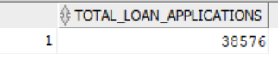

**--MTD Loan Applications**

SELECT COUNT (ID)AS MTD_TOTAL_LOAN_APPLICATIONS FROM BANK_LOAN_DATA WHERE EXTRACT (MONTH FROM TO_DATE (ISSUE_DATE, 'DD-MM-YY')) = 12 AND EXTRACT (YEAR FROM TO_DATE (ISSUE_DATE, 'DD-MM-YY')) = 2021;

**--PMTD Loan Applications**

SELECT COUNT (ID)AS PMTD_TOTAL_LOAN_APPLICATIONS FROM BANK_LOAN_DATA WHERE EXTRACT (MONTH FROM TO_DATE (ISSUE_DATE, 'DD-MM-YY')) = 11AND EXTRACT (YEAR FROM TO_DATE (ISSUE_DATE, 'DD-MM-YY')) = 2021;

**--Total Loan Amount**

SELECT SUM (LOAN_AMOUNT) AS TOTAL_LOAN_AMOUNT FROM BANK_LOAN_DATA;

**--MTD Total Loan Amount**

SELECT SUM (LOAN_AMOUNT) AS TOTAL_LOAN_AMOUNT FROM BANK_LOAN_DATA WHERE EXTRACT (MONTH FROM TO_DATE (ISSUE_DATE ,'DD-MM-YY')) = 12 AND EXTRACT (YEAR FROM TO_DATE (ISSUE_DATE,'DD-MM-YY')) = 2021;

**--PMTD Total Loan Amount**

SELECT SUM (LOAN_AMOUNT) AS TOTAL_LOAN_AMOUNT FROM BANK_LOAN_DATA WHERE EXTRACT (MONTH FROM TO_DATE (ISSUE_DATE ,'DD-MM-YY')) = 11 AND EXTRACT (YEAR FROM TO_DATE (ISSUE_DATE,'DD-MM-YY')) = 2021;

**Financial KPIs**

**--TOTAL PAYMENT SUM**

SELECT SUM(TOTAL_PAYMENT) AS TOTAL_PAYMENT FROM BANK_LOAN_DATA;

**--MTD TOTAL PAYMENT SUM**

SELECT SUM (TOTAL_PAYMENT) AS MTD_TOTAL_PAYMENT FROM BANK_LOAN_DATA

WHERE EXTRACT (MONTH FROM TO_DATE (ISSUE_DATE, 'DD-MM-YY')) = 12

AND EXTRACT (YEAR FROM TO_DATE (ISSUE_DATE, 'DD-MM-YY')) = 2021;

**--PMTD TOTAL PAYMENT SUM**

SELECT SUM (TOTAL_PAYMENT) AS PMTD_TOTAL_PAYMENT FROM BANK_LOAN_DATA

WHERE EXTRACT (MONTH FROM TO_DATE (ISSUE_DATE, 'DD-MM-YY')) = 11

AND EXTRACT (YEAR FROM TO_DATE (ISSUE_DATE, 'DD-MM-YY')) = 2021;



**Interest Rate and DTI-**

**--AVG Interest rate**

SELECT ROUND (AVG(INT_RATE), 4) *100 AS INTEREST_DATE FROM BANK_LOAN_DATA;

**--MTD AVG Interest rate**

SELECT ROUND (AVG(INT_RATE), 4) *100 AS MTD_INTEREST_DATE FROM BANK_LOAN_DATA

WHERE EXTRACT (MONTH FROM TO_DATE (ISSUE_DATE, 'DD-MM-YY')) = 12

AND EXTRACT (YEAR FROM TO_DATE (ISSUE_DATE, 'DD-MM-YY')) = 2021;

**--PMTD AVG Interest rate**

SELECT ROUND (AVG(INT_RATE), 4) *100 AS PMTD_INTEREST_DATE FROM BANK_LOAN_DATA

WHERE EXTRACT (MONTH FROM TO_DATE (ISSUE_DATE, 'DD-MM-YY')) = 11

AND EXTRACT (YEAR FROM TO_DATE (ISSUE_DATE, 'DD-MM-YY')) = 2021;

**--AVG DTI**

SELECT ROUND (AVG(DTI), 4) *100 AS AVG_DTI FROM BANK_LOAN_DATA;

**--MTD AVG DTI**

SELECT ROUND (AVG(DTI), 4) *100 AS MTD_AVG_DTI FROM BANK_LOAN_DATA

WHERE EXTRACT (MONTH FROM TO_DATE (ISSUE_DATE, 'DD-MM-YY')) = 12

AND EXTRACT (YEAR FROM TO_DATE (ISSUE_DATE, 'DD-MM-YY')) = 2021;



**--PMTD AVG DTI**

SELECT ROUND (AVG(DTI), 4) *100 AS PMTD_AVG_DTI FROM BANK_LOAN_DATA

WHERE EXTRACT (MONTH FROM TO_DATE (ISSUE_DATE, 'DD-MM-YY')) = 11

AND EXTRACT (YEAR FROM TO_DATE (ISSUE_DATE, 'DD-MM-YY')) = 2021;

**Good vs Bad Loan Analysis**

**--Good Loan Percentage**

SELECT ROUND ((SUM (CASE

WHEN LOAN_STATUS IN ('Fully Paid', 'Current') THEN 1

ELSE 0 END) * 100) / COUNT(*), 2 ) AS GOOD_LOAN_PERCENTAGE

FROM BANK_LOAN_DATA;

**--Good Loan Applications**

SELECT COUNT(ID) AS GOOD_LOAN_APPLICATIONS FROM BANK_LOAN_DATA

WHERE LOAN_STATUS = 'Fully Paid' OR LOAN_STATUS = 'Current';

**--Good Loan Funded Amount**

SELECT SUM (LOAN_AMOUNT) AS GOOD_LOAN_FUNDED_AMOUNT FROM BANK_LOAN_DATA

WHERE LOAN_STATUS = 'Fully Paid' OR LOAN_STATUS = 'Current';

**--Good Loan Received Amount**

SELECT SUM (TOTAL_PAYMENT) AS GOOD_LOAN_RECEIVED_AMOUNT FROM BANK_LOAN_DATA

WHERE LOAN_STATUS = 'Fully Paid' OR LOAN_STATUS = 'Current';

**--Bad Loan Percentage**

SELECT ROUND ((SUM (CASE

WHEN LOAN_STATUS = 'Charged Off' THEN 1 ELSE 0 END) * 100) / COUNT(*), 2) AS BAD_LOAN_PERCENTAGE

FROM BANK_LOAN_DATA;

**--Bad Loan Applications**

SELECT COUNT(ID) AS BAD_LOAN_APPLICATIONS FROM BANK_LOAN_DATA

WHERE LOAN_STATUS = 'Charged Off';



**--Bad Loan Funded Amount**

SELECT SUM (LOAN_AMOUNT) AS BAD_LOAN_FUNDED_AMOUNT FROM BANK_LOAN_DATA

WHERE LOAN_STATUS = 'Charged Off';

**--Bad Loan Received Amount**

SELECT SUM (TOTAL_PAYMENT) AS BAD_LOAN_RECEIVED_AMOUNT FROM BANK_LOAN_DATA

WHERE LOAN_STATUS = 'Charged Off';

**--Loan Status**

SELECT LOAN_STATUS,

COUNT(ID) AS TOTAL_LOAN_APPLICATIONS,

SUM (TOTAL_PAYMENT) AS TOTAL_AMOUNT_RECEIVED,

SUM (LOAN_AMOUNT) AS TOTAL_FUNDED_AMOUNT,

AVG (INT_RATE*100) AS INTREST_RATE,

AVG (DTI*100) AS dti FROM BANK_LOAN_DATA

GROUP BY LOAN_STATUS;



**--MTD Amount received and funded**

SELECT LOAN_STATUS,

SUM (TOTAL_PAYMENT) AS MTD_TOTAL_AMOUNT_RECEIVED,

SUM (LOAN_AMOUNT) AS MTD_TOTAL_FUNDED_AMOUNT

FROM BANK_LOAN_DATA

WHERE EXTRACT (MONTH FROM TO_DATE (ISSUE_DATE, 'DD-MM-YY')) = 12

GROUP BY LOAN_STATUS;

**Monthly Trends**

**--Monthly Trends by Issue date**

SELECT

TO_CHAR (ISSUE_DATE, 'MM') AS MONTH_NUMBER,

TO_CHAR (ISSUE_DATE , 'Month') AS MONTH_NAME,

COUNT(ID) AS TOTAL_LOAN_APPLICATIONS,

SUM (LOAN_AMOUNT) AS TOTAL_FUNDED_AMOUNT,

SUM (TOTAL_PAYMENT) AS TOTAL_RECEIVED_AMOUNT

FROM BANK_LOAN_DATA

GROUP BY TO_CHAR(ISSUE_DATE,'MM'), TO_CHAR (ISSUE_DATE, 'Month')

ORDER BY TO_CHAR (ISSUE_DATE, 'MM');

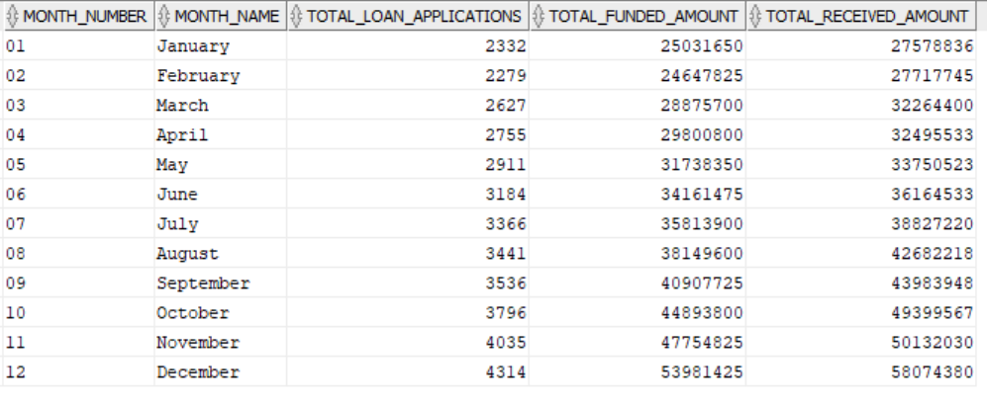

**Regional Breakdown**

**--Regional Analysis by State**

SELECT ADDRESS_STATE,

COUNT(ID) AS TOTAL_LOAN_APPLICATIONS,

SUM (LOAN_AMOUNT) AS TOTAL_FUNDED_AMOUNT,

SUM (TOTAL_PAYMENT) AS TOTAL_RECEIVED_AMOUNT

FROM BANK_LOAN_DATA

GROUP BY ADDRESS_STATE

ORDER BY TOTAL_FUNDED_AMOUNT DESC;

**Categorical Insights**

**--Loan Term Analysis**

SELECT TERM,

COUNT(ID) AS TOTAL_LOAN_APPLICATIONS,

SUM (LOAN_AMOUNT) AS TOTAL_FUNDED_AMOUNT,

SUM (TOTAL_PAYMENT) AS TOTAL_RECEIVED_AMOUNT

FROM BANK_LOAN_DATA

GROUP BY TERM

ORDER BY TERM ;

**--Employee Length Analysis**

SELECT EMP_LENGTH,

COUNT(ID) AS TOTAL_LOAN_APPLICATIONS,

SUM (LOAN_AMOUNT) AS TOTAL_FUNDED_AMOUNT,

SUM (TOTAL_PAYMENT) AS TOTAL_RECEIVED_AMOUNT

FROM BANK_LOAN_DATA

GROUP BY EMP_LENGTH

ORDER BY EMP_LENGTH ;

**--Loan Purpose Breakdown**

SELECT PURPOSE,

COUNT(ID) AS TOTAL_LOAN_APPLICATIONS,

SUM (LOAN_AMOUNT) AS TOTAL_FUNDED_AMOUNT,

SUM (TOTAL_PAYMENT) AS TOTAL_RECEIVED_AMOUNT

FROM BANK_LOAN_DATA

GROUP BY PURPOSE

ORDER BY COUNT(ID) DESC ;

**--Home Ownership Analysis**

SELECT HOME_OWNERSHIP,

COUNT(ID) AS TOTAL_LOAN_APPLICATIONS,

SUM (LOAN_AMOUNT) AS TOTAL_FUNDED_AMOUNT,

SUM (TOTAL_PAYMENT) AS TOTAL_RECEIVED_AMOUNT

FROM BANK_LOAN_DATA

GROUP BY HOME_OWNERSHIP

ORDER BY COUNT(ID) DESC ;

